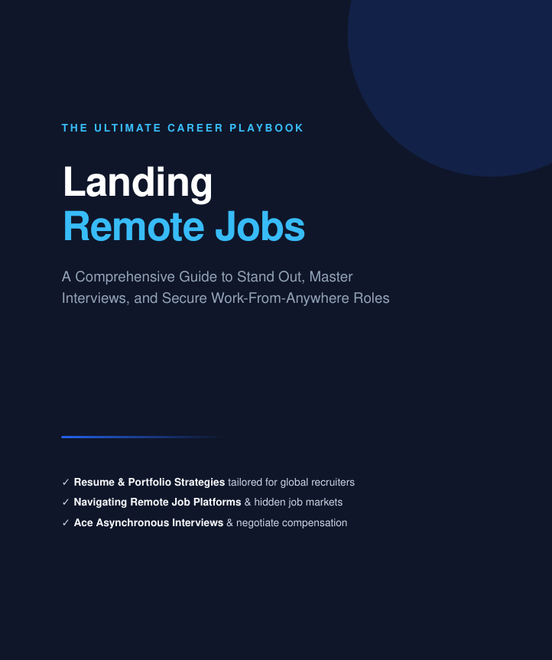

INTRODUCTION
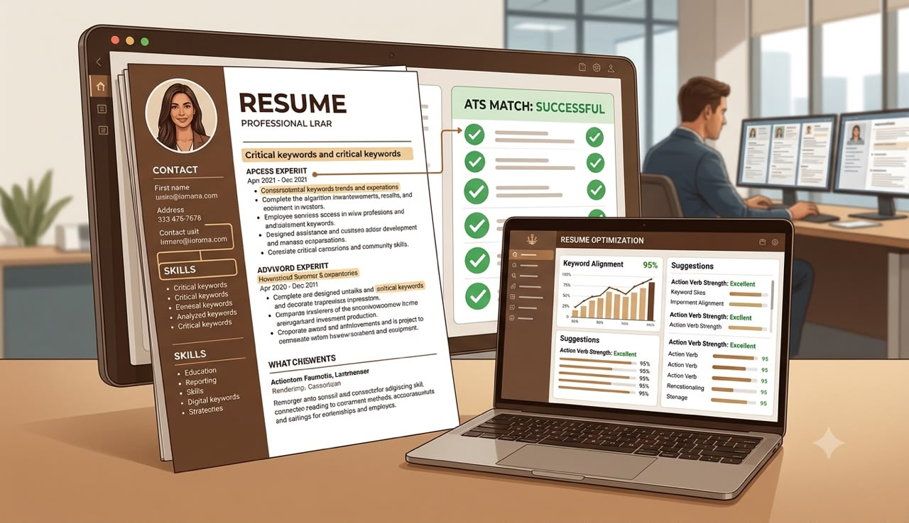
Before We Begin...
If you're reading this, chances are you've experienced at least one of these.
You've spent hours scrolling through LinkedIn.
You've applied to dozens of jobs without hearing back.
You've paid someone for a "sure" remote job lead that disappeared after collecting your money.
You've watched people on social media announce new remote jobs while wondering:
"What exactly are they doing differently?"
I know that feeling.
It can make you question your abilities.
It can make you feel like everyone else has discovered a secret that somehow escaped you.
But here's what I want you to know before we go any further:
You probably don't need another certificate.
You probably don't need to apply to another 300 jobs.
And you definitely don't need another WhatsApp "agent" promising guaranteed employment after you pay a fee.
Most people are working incredibly hard.
They're simply working with the wrong system.

The Biggest Lie About Remote Jobs
One of the biggest misconceptions is this:
"The more jobs you apply for, the higher your chances."
That sounds reasonable.
Unfortunately, it usually leads to frustration.
Many employers—especially international companies—receive hundreds of applications for a single remote position.
Recruiters often review applications quickly before deciding which candidates move forward.
That means sending the same CV to 200 companies rarely produces better results than sending 20 carefully targeted applications.
Quality almost always beats quantity.

Remote Jobs Are Real
Let's clear something up immediately.
Remote jobs are real.
People living in Nigeria genuinely work for companies in:
United States
United Kingdom
Canada
Germany
Australia
Netherlands
Singapore
They're employed as:
Customer Support Specialists
Virtual Assistants
Project Coordinators
Data Analysts
Designers
Software Developers
Writers
Digital Marketers
Recruiters
Sales Representatives
Operations Specialists
The opportunity exists.
The challenge is knowing how to position yourself.

What This Guide Is—and Isn't
This guide is not a magic formula.
It cannot guarantee anyone a job.
No honest career guide can.
Companies make hiring decisions based on many factors beyond your control.
What this guide can do is help you improve the parts you can control.
You'll learn how to:
Search smarter.
Avoid scams.
Present yourself professionally.
Write stronger applications.
Improve your interview preparation.
Build systems that make your search more efficient.
Those improvements can increase your chances of getting interviews and legitimate opportunities, but they are not guarantees of employment.

Why I Structured This Guide Differently
Most career guides dump information on you.
This one gives you a process.
Think of it like learning to cook.
Someone can hand you ingredients.
That doesn't mean you'll prepare a good meal.
You need the recipe.
The timing.
The order.
The method.
Remote job searching works the same way.
The order matters.
That's why this guide follows one simple framework.
FIND
↓
VET
↓
GET HIRED
We'll build each step together.

What You'll Learn
By the time you finish this guide you'll know how to:
✔ Find legitimate remote opportunities.
✔ Recognize warning signs before scammers waste your time or money.
✔ Build an ATS-friendly CV.
✔ Improve your LinkedIn profile.
✔ Write better cover letters.
✔ Prepare confidently for interviews.
✔ Negotiate professionally.
✔ Build a repeatable job-search routine.
You'll also receive practical tools you can begin using immediately, including:
Checklists
Templates
Scripts
Trackers
Worksheets
Action plans

A Small Promise
I want to make you one promise.
I'm not promising you'll receive an offer next week.
I'm not promising you'll earn dollars in 30 days.
What I am promising is this:
If you genuinely apply the strategies in this guide, you'll stop guessing.
You'll know what to do next.
Instead of waking up every morning wondering,
"Where should I even start today?"
you'll already have a clear roadmap.
And sometimes, that's the biggest difference between staying stuck and moving forward.

Before You Turn the Page
Don't rush through this guide.
Complete every worksheet.
Fill in every checklist.
Customize every template.
Take action before moving to the next chapter.
Reading won't change your life.
Applying what you read might.
So grab your notebook.
Open your laptop.
And let's begin building a remote career the smart way—not the stressful way.
Turn the page.
Your journey starts now.

CHAPTER ONE
Build Your Remote Job Foundation in 30 Minutes

Build Your Remote Job Foundation in 30 Minutes
Stop Applying for Jobs... Just for Today
I know that sounds strange.
You've probably opened this guide because you want a remote job as quickly as possible. So telling you to pause before applying may seem like the wrong advice.
But hear me out.
Imagine trying to build a house on soft sand. No matter how beautiful the walls look, they'll eventually crack because the foundation wasn't solid.
Your job search works the same way.
Many people spend months applying for jobs with:
An outdated CV.
An incomplete LinkedIn profile.
No system for tracking applications.
Documents scattered across different devices.
No clear idea which jobs they've already applied for.
Then they wonder why everything feels chaotic.
Before we start chasing opportunities, let's build a foundation that makes every future application stronger.
This is the first win I want you to experience.

Your First Quick Win
Here's my challenge for you:
Don't spend the next 30 minutes applying for jobs.
Instead, spend those 30 minutes preparing to apply better.
By the time you're done, you'll have:
A professional job-search workspace.
A better online presence.
Organized application documents.
A system you'll use throughout this guide.
You may not receive an interview today—but you'll remove many of the small problems that quietly sabotage job seekers.

Step 1: Create a Professional Email Address
Your email address is often the first thing a recruiter sees.
If yours looks like this:
coolboy123@email.com
queen4life@email.com
footballking@email.com
it's time for an upgrade.
Instead, use something simple and professional:
firstname.lastname@email.com
firstnamelastname@email.com
firstname.lastname.work@email.com (if your preferred address is already taken)
Keep it clean. Keep it memorable.
If you already have a professional email address, great. Move on to the next step.

Step 2: Organize Your Job Search Folder
One habit separates organized job seekers from frustrated ones:
They know where everything is.
Create a folder on your computer called:
Remote Job Search
Inside it, create these folders:
CVs
Cover Letters
Certificates
Portfolio
References
Interview Notes
Job Descriptions
Offer Letters
Why does this matter?
Because when a recruiter emails you asking for an updated CV or certificate, you shouldn't spend 20 minutes searching your Downloads folder.
Being organized also reduces stress. You'll know exactly where every important document lives.

Step 3: Update Your Contact Information
Open your CV.
Now check the basics:
✔ Is your phone number correct?
✔ Is your email address current?
✔ Does your LinkedIn URL work?
✔ Are there spelling mistakes?
✔ Is your location accurate?
If you've moved recently or changed your number, update it now.
It sounds obvious, but many qualified candidates miss opportunities because recruiters can't reach them.

Step 4: Create a Master CV
This is one mistake I made myself.
I kept rewriting my only CV.
Eventually I couldn't remember which version contained my best achievements.
Instead, create one Master CV.
Think of it as your personal database.
Include:
Every job you've held.
Every certification.
Every skill.
Every project.
Every measurable achievement.
Don't worry if it's long.
This document isn't for employers.
It's for you.
Whenever you apply for a specific role, you'll copy relevant information from your Master CV into a tailored version instead of starting from scratch.
You'll save hours over time.

Step 5: Clean Up Your LinkedIn Profile
If a recruiter searches your name today, what will they see?
Take five minutes and review your profile.
Ask yourself:
Is my profile photo professional?
Does my headline describe what I do?
Have I completed my About section?
Does my experience match my CV?
Have I listed my skills?
Don't try to make it perfect today.
The goal is simply to make it accurate and complete.
We'll improve it further in a later chapter.

Step 6: Set Up Job Alerts
Many people waste hours refreshing job boards.
Instead, let opportunities come to you.
Visit your preferred job platforms and create alerts for roles that match your experience.
Examples include:
Customer Support
Virtual Assistant
Project Coordinator
Data Analyst
Content Writer
Social Media Manager
Use filters that fit your goals, such as:
Remote
Full-Time
Contract
Entry-Level (if appropriate)
Once the alerts are active, you'll spend less time searching and more time applying strategically.

Tool 1: Remote Job Readiness Checklist
Before you move to Chapter Two, complete this checklist.
Don't tick a box because you intend to do it.
Tick it only after you've done it.

A Word Before You Continue
At this point, you might feel like you haven't really "started" looking for a job.
In reality, you've done something more valuable.
You've built the systems that will make every application from this point forward more organized, more professional, and easier to manage.
Think of it this way:
The person who spends 30 minutes building a strong foundation today often saves hours of frustration over the next few months.
And that's exactly the kind of progress we're aiming for—not shortcuts, but smarter habits that compound over time.

Tool 2: Remote Job Readiness Scorecard
Before moving to Chapter Two, take a few minutes to assess your current readiness. Be honest—this isn't a test. It's simply a way to identify areas that need attention.
Give yourself:
2 points if the statement is completely true.
1 point if it's partly true.
0 points if it's not true.
Total Score
16–20 points
Excellent foundation. You're ready to begin applying strategically.
10–15 points
Good start. Strengthen the weaker areas before increasing the number of applications you send.
0–9 points
Don't worry. You're exactly where many people begin. Use this guide to build your system one step at a time.

Tool 3: Weekly Job Search Planner
Many people think job searching means applying every day from morning until night.
In reality, structure beats randomness.
Use this planner to stay focused without burning yourself out.
Monday – Opportunity Day
Check your job alerts.
Save interesting vacancies.
Read job descriptions carefully.
Research companies.
Goal: Find 5–10 quality opportunities.

Tuesday – CV Day
Tailor your CV for each role.
Don't change everything.
Adjust:
Professional summary.
Skills section.
Keywords.
Relevant achievements.
Goal: Prepare 3–5 tailored CVs.

Wednesday – Application Day
Submit your applications.
Double-check:
Attachments.
File names.
Cover letter.
Contact details.
Quality is more important than speed.

Thursday – Networking Day
Spend at least 30 minutes:
Connecting with recruiters.
Engaging with industry posts.
Commenting professionally.
Joining relevant LinkedIn groups.
Networking isn't begging for jobs.
It's making yourself visible.

Friday – Follow-Up Day
Review applications sent earlier.
Send polite follow-up emails where appropriate.
Update your tracker.
Celebrate small wins—even if it's simply completing your weekly plan.

Saturday
Learn something new.
Examples:
Excel
Customer Support
Google Workspace
Project Management
Communication Skills
Improving your skills increases your future opportunities.

Sunday
Rest.
Review the week.
Plan the next one.
Consistency is easier when you leave room to recover.

Tool 4: Daily Application Tracker
Create a table like this in a notebook or spreadsheet.
Don't rely on memory.
Tracking helps you:
Avoid duplicate applications.
Remember when to follow up.
Spot patterns in your job search.

Your 30-Minute Action Challenge
Set a timer for 30 minutes.
Complete as many of these tasks as you can:
☐ Create a professional email address.
☐ Organize your job-search folders.
☐ Update your CV contact details.
☐ Create a Master CV.
☐ Review your LinkedIn profile.
☐ Set up at least three job alerts.
☐ Start your application tracker.
When the timer ends, stop.
The goal isn't perfection.
The goal is momentum.

Reflection Exercise
Take five minutes to answer these questions honestly.
1. What has been your biggest challenge so far?

2. Which mistake do you think you've been making most often?
□ Applying randomly
□ Using one CV for every job
□ Falling for fake opportunities
□ Not networking
□ Giving up too quickly
□ Other: ________________________
3. What will you do differently starting today?

4. What remote role are you targeting first?

5. Why is getting a remote job important to you?
Write your answer in one sentence.

Keep this page. Return to it whenever you feel discouraged. Your answer will remind you why you started.

Key Lessons from Chapter One
Before you move on, remember these five principles:
Preparation beats panic. A well-organized system reduces stress and saves time.
Professionalism starts before the interview. Your email, documents, and online profile shape first impressions.
Quality beats quantity. Sending fewer, well-prepared applications is usually more effective than sending many generic ones.
Consistency wins. Small, regular actions build momentum over time.
Systems create confidence. When you know what to do each day, job searching feels less overwhelming.

Chapter One Challenge
Before you read Chapter Two, make this promise to yourself:
"For the next 30 days, I will follow a structured job-search routine. I will improve my applications instead of simply increasing the number I send. I will stay organized, keep learning, and focus on steady progress rather than quick fixes."
Write today's date here:
Date: ___________________________
Sign your name:
Signature: ______________________
This simple commitment marks the beginning of a more intentional approach to your job search.

CHAPTER TWO
FIND: Where Legitimate Dollar-Paying Remote Jobs Are Actually Posted
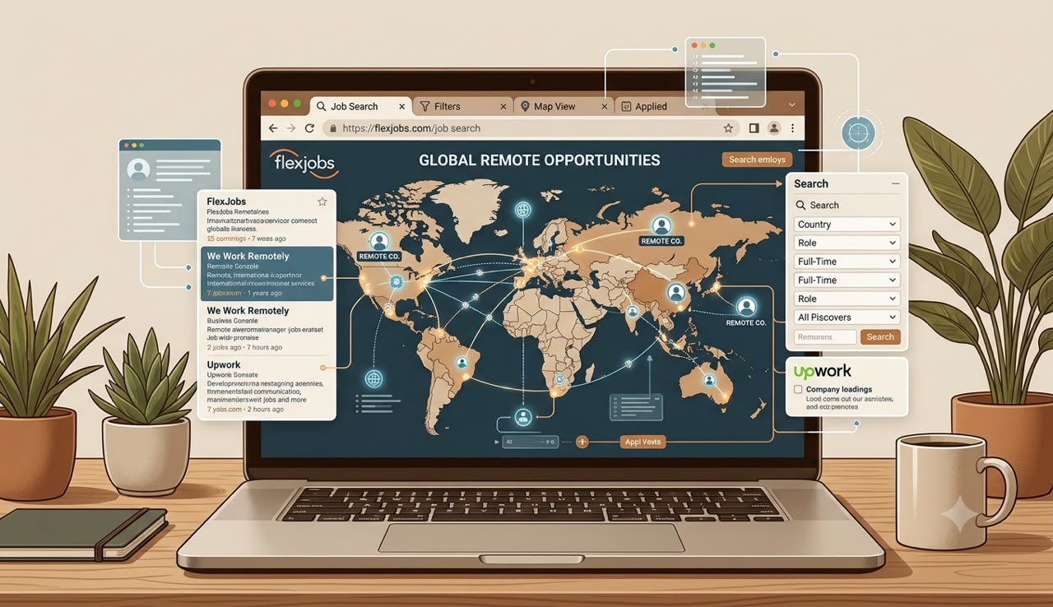
FIND: Where Legitimate Dollar-Paying Remote Jobs Are Actually Posted
Stop Looking Everywhere
When I first started looking for remote jobs, I thought the internet worked like a giant supermarket.
I believed every website had the same opportunities.
So every morning I opened ten tabs.
One after another.
Refresh.
Refresh.
Refresh again.
Hours disappeared.
At the end of the day, I had applied for plenty of jobs—but very few were actually good opportunities.
Some had already been filled.
Some were reposted over and over.
Some weren't even real.
I was busy.
But I wasn't making progress.
That changed when I stopped asking:
"Where are the most jobs?"
and started asking:
"Where are the right employers?"
Those are two very different questions.

Think Like a Recruiter
Here's something many job seekers forget.
Companies don't wake up every morning thinking,
"How can we make life easier for applicants?"
They simply want to hire the right person.
Different companies recruit in different places.
Some only advertise on LinkedIn.
Others only use their own careers page.
Some recruit through trusted remote-job platforms.
A few never advertise publicly—they search LinkedIn instead.
That's why successful job seekers don't rely on one website.
They build a system.

Your Remote Job Search Pyramid
Instead of checking random websites every day, divide your search into four levels.
Level One: Company Career Pages
This should be your highest priority.
Many companies advertise openings on their own websites before—or instead of—posting them elsewhere.
Why?
Because applicants who visit a company's careers page often show genuine interest in that organization.
Create a list of companies you'd like to work for and check their careers page regularly.

Level Two: Professional Job Platforms
Use established job boards that allow you to search by location, job type, experience level, and remote status.
Examples include:
LinkedIn Jobs
Indeed
Wellfound
We Work Remotely
Remote OK
Jobspresso
Working Nomads
Don't feel pressured to use every platform.
Choose two or three that consistently match your target role.
Master those first.

Level Three: Professional Networking
Many jobs are filled because someone knew someone.
That doesn't mean you need powerful connections.
It means you need to become visible.
Start by:
Following companies you admire.
Connecting with recruiters in your field.
Engaging thoughtfully with industry posts.
Sharing occasional updates about your learning or projects.
The goal isn't to beg for work.
It's to build a professional presence over time.

Level Four: Referrals
A referral doesn't guarantee an interview.
But it may help your application get noticed.
If someone you know works at a company you're interested in, ask respectfully if they can explain the hiring process or let you know about suitable openings.
Avoid asking strangers for referrals before you've built any relationship with them.

Don't Search Like Everyone Else
Most people search like this:
Remote Job
That's too broad.
Instead, search for your specific role.
Examples:
Remote Customer Support
Remote Executive Assistant
Remote Data Entry
Remote Virtual Assistant
Remote Bookkeeper
Remote Graphic Designer
Remote Content Writer
The more specific your search, the more relevant your results tend to be.

Learn to Read Job Descriptions
Many applicants skim job descriptions for ten seconds.
Don't make that mistake.
Read carefully.
Look for:
Responsibilities
What will you actually be doing?
Required Skills
Which skills are essential?
Preferred Skills
Which skills can you develop over time?
Time Zone Requirements
Some remote jobs expect you to work specific hours.
Employment Type
Full-time
Part-time
Contract
Freelance
Understanding these details helps you decide whether the role genuinely fits your situation.

Don't Ignore Smaller Companies
Many people only apply to famous companies.
That creates enormous competition.
Smaller businesses, startups, and growing remote-first companies may also offer rewarding opportunities.
They often value practical skills, flexibility, and a willingness to learn.
Keep an open mind.

Set Up Job Alerts
Don't rely on memory.
Let technology help you.
Create alerts for roles that match your interests.
For example:
Keywords
Customer Support
Virtual Assistant
Content Writer
Project Coordinator
Location
Remote
Experience
Entry-Level (if appropriate)
When new vacancies are posted, you'll receive notifications instead of spending hours searching manually.

Tool 1: The FIND Map
Complete this table.
My Target Roles

My Preferred Industries
☐ Technology
☐ Finance
☐ Education
☐ Healthcare
☐ Marketing
☐ E-commerce
☐ Customer Service
☐ Other:

Companies I Want to Work For
Write ten companies you'd genuinely like to join.

This list becomes your "watch list."
Review it regularly for new openings.

Tool 2: Weekly Opportunity Tracker
Use this table every week.
Your goal isn't to apply for everything.
Your goal is to identify quality opportunities.

The 70/20/10 Rule
To avoid putting all your effort into one type of job search, try dividing your weekly activities:
70% — Apply for suitable advertised roles.
20% — Build your professional network by connecting with people in your field and engaging with relevant content.
10% — Learn a new skill or improve an existing one.
This balance helps you keep progressing even if applications are slow.

Common Mistakes to Avoid
As you build your FIND system, watch out for these habits:
Applying for every remote job you see, regardless of fit.
Ignoring the full job description.
Relying only on social media job posts.
Using the same search terms every day.
Failing to track where you've applied.
Assuming every remote job is legitimate.

Chapter Two Challenge
Over the next 48 hours:
☐ Create a list of 10 companies you'd like to work for.
☐ Set up job alerts for three target roles.
☐ Save five high-quality vacancies, even if you don't apply immediately.
☐ Complete your Weekly Opportunity Tracker.
☐ Read at least three job descriptions from start to finish.
Don't worry about applying yet.
Your goal is to become skilled at identifying good opportunities.
That's the foundation of a smarter job search.

Key Lessons from Chapter Two
By now you should understand that finding remote jobs isn't about checking every website on the internet.
It's about creating a focused system.
Remember these principles:
Search intentionally. A smaller number of relevant opportunities is more valuable than hundreds of random listings.
Prioritize quality sources. Company career pages and established job platforms are generally more reliable than forwarded messages or unverified posts.
Stay organized. Tracking opportunities helps you avoid confusion and follow up effectively.
Think long-term. Networking and skill development are part of the job search—not separate activities.

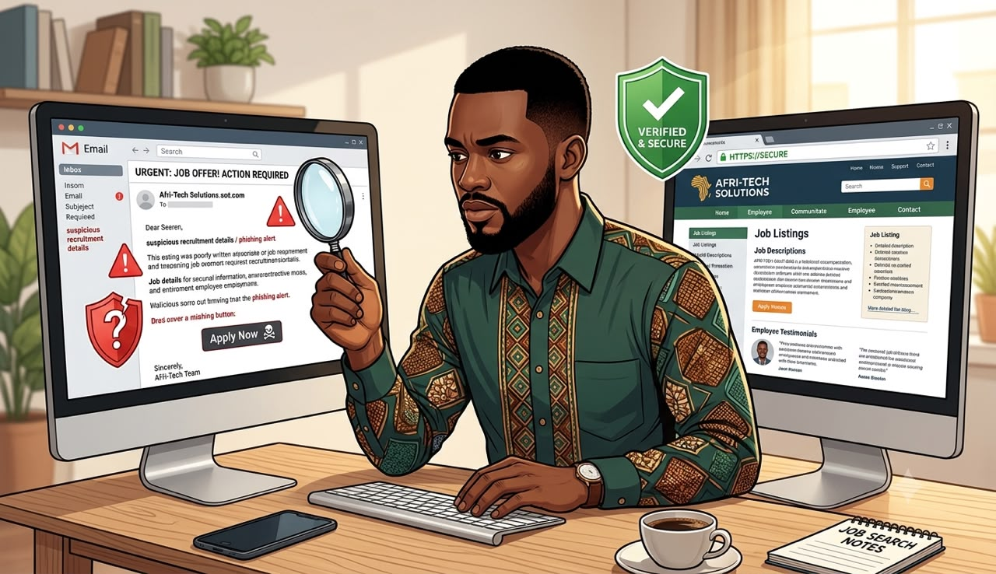
CHAPTER THREE
VET: How to Spot Fake Recruiters Before They Scam You
The Most Expensive Mistake I Ever Made. I still remember the message. It looked professional.
The company logo was there.
The salary sounded amazing.
The recruiter spoke confidently.
Everything looked real.
Then came one sentence.
"To secure your interview slot, kindly pay a refundable processing fee."
I wanted the job badly.
So I convinced myself it made sense.
Maybe this company was different.
Maybe international companies really charged processing fees.
Maybe this was normal.
It wasn't.
The money disappeared.
The recruiter disappeared.
The phone number stopped working.
And I was left with two painful lessons:
First, losing money hurts.
Second, losing trust hurts even more.
If you've ever fallen for a fake opportunity, you're not foolish.
Scammers succeed because they're skilled at creating urgency and making fake opportunities look genuine.
The good news is that many scams follow predictable patterns.
Once you know what to look for, you'll become much harder to deceive.
________________________________________
Why Job Seekers Are Easy Targets
Think about the emotions many job seekers carry.
Hope.
Pressure.
Bills.
Family expectations.
Fear of missing out.
Scammers understand this.
They know someone who has been unemployed for months may ignore warning signs because they desperately want good news.
That's why your first job isn't applying.
Your first job is verifying.
________________________________________
Rule Number One
No Legitimate Employer Can Guarantee You a Job
Be careful whenever someone says:
"100% guaranteed employment."
"Pay first."
"Only today."
"Limited interview slots."
Professional employers hire people through a recruitment process.
No honest recruiter can promise you'll get the role before evaluating your qualifications.
________________________________________
Rule Number Two
Never Pay to Get Hired
This rule is simple.
If someone asks you to pay money before you can start working, stop and investigate carefully.
Examples include requests for:
• Registration fees
• Processing fees
• Interview fees
• Equipment deposits
• Security payments
• Training fees that must be paid before employment
Some legitimate employers may ask employees to provide certain documents or complete background checks, but requests for upfront payments should always be treated with caution and verified independently.
________________________________________
Rule Number Three
Verify the Company
Before you apply—or respond to a recruiter—spend ten minutes researching.
Visit the company's official website.
Does it look complete?
Is there a careers page?
Does the company explain what it does?
Can you find contact information?
Then search for the company on LinkedIn.
Look for:
• Company profile
• Employees
• Recent posts
• Business activity
An active online presence doesn't automatically prove legitimacy, but it can help you evaluate whether the organization appears established.
________________________________________
Rule Number Four
Check the Recruiter's Email Address
Scammers often use free email accounts that resemble company names.
For example:
companyrecruitment@gmail.com
instead of
careers@company.com
This doesn't automatically mean the opportunity is fake, but it should encourage you to verify the recruiter through the company's official website before sharing sensitive information.
________________________________________
Rule Number Five
Read the Job Description Carefully
Some fake vacancies reveal themselves through poor details.
Watch for:
• Extremely vague responsibilities.
• Unrealistic salaries with little explanation.
• Poor spelling and grammar throughout the posting.
• Pressure to respond immediately.
• Missing company information.
• No interview process described.
A professional employer usually explains the role, responsibilities, qualifications, and application process clearly.
________________________________________
When an Offer Sounds Too Good
Imagine seeing this advert:
Work only two hours a day.
Earn thousands of dollars every week.
No experience required.
Immediate employment.
Unlimited positions available.
Could it be genuine?
Possibly.
But extraordinary promises deserve extra scrutiny.
Instead of getting excited immediately, ask yourself:
• Does this make business sense?
• Why would a company pay so much for so little?
• Can I verify this employer elsewhere?
Healthy skepticism protects you.
________________________________________
Protect Your Personal Information
Before you've confirmed an employer is legitimate, avoid sharing unnecessary personal details.
For example:
• Bank account information.
• Debit or credit card details.
• BVN or other sensitive financial information.
• Copies of identity documents unless they're required later in a verified hiring process.
Share information gradually and only when you're confident you're dealing with a genuine employer.
________________________________________
Tool 1: The Remote Job Vetting Checklist
Before applying for any remote role, answer these questions.
Question Yes No
Does the company have an official website? ☐ ☐
Is the job listed on the company's careers page or another trusted source? ☐ ☐
Can you find the company on LinkedIn? ☐ ☐
Can you identify employees connected to the company? ☐ ☐
Is the job description detailed and professional? ☐ ☐
Is the recruiter using a professional company email address? ☐ ☐
Have they avoided asking for upfront payments? ☐ ☐
Does the salary seem realistic for the role? ☐ ☐
Is there a clear interview process? ☐ ☐
Have you independently verified the company? ☐ ☐
How to Use It
• 9–10 Yes answers: The opportunity appears well-supported. Continue with normal caution.
• 6–8 Yes answers: Investigate further before applying or sharing sensitive information.
• 0–5 Yes answers: Treat the opportunity as high risk until you can verify it.
This checklist doesn't guarantee a job is legitimate, but it helps you ask the right questions before moving forward.
________________________________________
Tool 2: Scam Warning Log
Keep a simple record of suspicious opportunities.
Date Company Concern Action Taken

Writing these down helps you notice patterns and avoid repeating mistakes.
________________________________________
A Five-Minute Verification Routine
Before you click Apply, spend five minutes answering these questions:
1. Who is hiring?
Can I identify the employer?
2. What evidence supports this opportunity?
Official website? Company LinkedIn page? Careers page?
3. What are the warning signs?
Urgency, vague descriptions, payment requests, or inconsistent contact details?
4. Would I recommend this opportunity to a close friend?
If your answer is "I'm not sure," pause and investigate further.
________________________________________
Chapter Three Challenge
Over the next two days:
☐ Verify three companies using the Vetting Checklist.
☐ Research one recruiter before responding to a message.
☐ Save the websites of five companies you trust.
☐ Record one suspicious opportunity in your Scam Warning Log—even if you choose not to apply.
By building this habit now, you'll spend less time chasing fake opportunities and more time focusing on genuine ones.
________________________________________
Key Lessons from Chapter Three
Before moving on, remember these principles:
1. Excitement should never replace verification.
2. A professional hiring process is transparent, not rushed.
3. Protect your personal and financial information.
4. Research first, apply second.
5. A consistent vetting routine can save you time, money, and unnecessary disappointment.

CHAPTER FOUR
Build an ATS-Friendly CV That Gets Noticed
Your CV Is Not Your Life Story
One of the biggest mistakes I made early in my job search was believing my CV had to include everything I'd ever done.
Every workshop.
Every seminar.
Every volunteer activity.
Every certificate.
My CV became longer.
But it didn't become better.
Then my mentor asked me one simple question.
"If you were hiring someone, would you read all of this?"
That question changed how I viewed my CV forever.
Your CV has one job.
Not to tell your entire life story.
Not to impress people with fancy words.
Not to show everything you've ever achieved.
Its job is simple:
Convince the recruiter that you're worth interviewing.
Nothing more.
Nothing less.
________________________________________
How Recruiters Actually Read CVs
Many job seekers imagine recruiters carefully reading every sentence.
Reality is different.
Recruiters often review many applications for the same role and need to decide quickly which candidates deserve closer attention.
That's why your CV must be easy to scan.
Within the first few moments, a recruiter should be able to answer these questions:
• Who is this person?
• What role are they applying for?
• Do they have relevant experience?
• What results have they achieved?
• Should I keep reading?
If those answers aren't immediately clear, your CV may be overlooked—even if you're qualified.
________________________________________
What Is an Applicant Tracking System (ATS)?
Many companies use software called an Applicant Tracking System (ATS) to organize applications.
Think of it as a digital filing cabinet.
It stores applications, helps recruiters search for candidates, and makes it easier to manage large numbers of applicants.
This doesn't mean the software decides everything.
Human recruiters still make hiring decisions.
But if your CV is difficult to read or doesn't clearly match the role, it may be harder for recruiters to find the information they're looking for.
The goal isn't to "beat" the ATS.
The goal is to make your CV clear for both the software and the recruiter.
________________________________________
Build One Master CV First
Remember the Master CV we created in Chapter One?
Now you'll understand why it matters.
Your Master CV is your personal archive.
It contains:
• Every job you've held.
• Every project.
• Every achievement.
• Every certification.
• Every skill.
• Every volunteer role.
• Every measurable result.
You never send this document to employers.
Instead, you copy relevant information into a shorter CV tailored to the specific role.
That way, every application feels focused instead of generic.
________________________________________
The Six Sections Every Strong CV Needs
Let's build your CV from the top down.
1. Contact Information
Keep it simple.
Include:
• Full name
• Professional email address
• Phone number
• City and country
• LinkedIn profile (if updated)
You don't need to include:
• Marital status
• Religion
• State of origin
• Nationality (unless specifically requested)
• Passport photograph (unless customary or requested)
Professionalism starts with simplicity.
________________________________________
2. Professional Summary
This is your introduction.
Keep it short.
Three to five sentences are enough.
Instead of saying:
"I am hardworking and dedicated."
Show value.
For example:
Customer Support Professional with three years of experience helping customers resolve technical issues and improve satisfaction. Skilled in CRM systems, written communication, and problem-solving. Seeking a remote role where I can deliver excellent customer experiences while contributing to team success.
Notice the difference.
It tells the recruiter:
• Who you are.
• What you've done.
• What you can offer.
________________________________________
3. Core Skills
List skills that are relevant to the job.
Examples:
Customer Support
Microsoft Excel
Google Workspace
CRM Software
Slack
Project Coordination
Communication
Problem Solving
Time Management
Only include skills you can genuinely demonstrate.
________________________________________
4. Work Experience
This is where many CVs become weak.
Don't simply describe your duties.
Show your impact.
Weak Example
Answered customer emails.
Better Example
Resolved customer enquiries through email and live chat while maintaining high customer satisfaction.
Even Better
Resolved more than 60 customer enquiries weekly through email and live chat while consistently meeting internal response-time targets.
Specific examples help recruiters understand the scale of your work.
If you don't have numbers, focus on clear achievements or responsibilities that demonstrate value.
________________________________________
5. Education
Include:
Qualification
Institution
Graduation year (optional if you prefer)
Relevant certifications
Keep this section clean and easy to read.
________________________________________
6. Additional Sections
Depending on your background, you may include:
Projects
Volunteer Experience
Languages
Technical Skills
Professional Certifications
Awards
Only include sections that strengthen your application.
________________________________________
Tailor Your CV for Every Application
One CV should not fit every job.
Before applying, compare your CV with the job description.
Ask yourself:
• Which skills does this employer value?
• Which experience is most relevant?
• Which achievements best demonstrate those skills?
Then adjust your CV accordingly.
You don't need to invent experience.
You simply highlight the experience that's most relevant to the role.
________________________________________
Use Strong Action Verbs
Replace weak phrases with stronger alternatives.
Instead of:
Helped
Worked on
Responsible for
Try:
Managed
Coordinated
Resolved
Improved
Developed
Implemented
Delivered
Supported
Organized
Led
Action verbs create a stronger first impression.
________________________________________
Keep the Design Simple
Fancy graphics may look attractive, but they aren't always necessary.
Choose:
• A readable font.
• Clear headings.
• Consistent spacing.
• Bullet points.
• Plenty of white space.
Your CV should be easy to scan, not difficult to decode.
________________________________________
Tool 1: ATS-Friendly CV Checklist
Before sending your CV, ask yourself:
☐ Is the role clearly stated?
☐ Does the professional summary match the job?
☐ Have I included relevant keywords from the job description?
☐ Are my achievements clear and specific?
☐ Is the formatting simple and consistent?
☐ Have I removed unnecessary information?
☐ Have I checked for spelling and grammar mistakes?
☐ Is my contact information correct?
☐ Have I saved the file with a professional name (e.g., Firstname_Lastname_CV.pdf)?
If you answered "No" to any of these, fix it before applying.
________________________________________
Tool 2: Achievement Builder Worksheet
Many people struggle to describe their work.
Use this simple formula:
Action + Task + Result
For example:
Action: Coordinated
Task: Customer onboarding
Result: Improved response times and reduced onboarding delays.
Now complete your own:
Action: _______________________
Task: _______________________
Result: _______________________
Repeat this exercise for five achievements. You'll quickly build stronger bullet points for your CV.
________________________________________
Common CV Mistakes to Avoid
Avoid these habits:
• Sending the same CV to every employer.
• Including unrelated information.
• Using long paragraphs.
• Listing responsibilities without showing impact.
• Forgetting to proofread.
• Saving files with names like CVfinalfinal2.pdf.
Small details can make a big difference.
________________________________________
Chapter Four Challenge
Before moving to Chapter Five:
☐ Update your professional summary.
☐ Rewrite at least five achievement statements using the Action + Task + Result formula.
☐ Tailor your CV for one specific job description.
☐ Proofread your CV carefully.
☐ Save it with a professional file name.
Don't aim for perfection.
Aim for clarity, relevance, and professionalism.
________________________________________
Key Lessons from Chapter Four
Remember these principles:
1. Your CV is a marketing document, not an autobiography.
2. Tailor your application to the role whenever possible.
3. Highlight achievements, not just responsibilities.
4. Keep the layout clean and easy to read.
5. Help the recruiter quickly understand why you're a strong candidate.
A strong CV won't guarantee an interview—but it gives employers a clearer picture of the value you can bring, which is exactly what you want.
CHAPTER FOUR
Build an ATS-Friendly CV That Gets Noticed
Your CV Is Not Your Life Story
One of the biggest mistakes I made early in my job search was believing my CV had to include everything I'd ever done.
Every workshop.
Every seminar.
Every volunteer activity.
Every certificate.
My CV became longer.
But it didn't become better.
Then my mentor asked me one simple question.
"If you were hiring someone, would you read all of this?"
That question changed how I viewed my CV forever.
Your CV has one job.
Not to tell your entire life story.
Not to impress people with fancy words.
Not to show everything you've ever achieved.
Its job is simple:
Convince the recruiter that you're worth interviewing.
Nothing more.
Nothing less.
________________________________________
How Recruiters Actually Read CVs
Many job seekers imagine recruiters carefully reading every sentence.
Reality is different.
Recruiters often review many applications for the same role and need to decide quickly which candidates deserve closer attention.
That's why your CV must be easy to scan.
Within the first few moments, a recruiter should be able to answer these questions:
• Who is this person?
• What role are they applying for?
• Do they have relevant experience?
• What results have they achieved?
• Should I keep reading?
If those answers aren't immediately clear, your CV may be overlooked—even if you're qualified.
________________________________________
What Is an Applicant Tracking System (ATS)?
Many companies use software called an Applicant Tracking System (ATS) to organize applications.
Think of it as a digital filing cabinet.
It stores applications, helps recruiters search for candidates, and makes it easier to manage large numbers of applicants.
This doesn't mean the software decides everything.
Human recruiters still make hiring decisions.
But if your CV is difficult to read or doesn't clearly match the role, it may be harder for recruiters to find the information they're looking for.
The goal isn't to "beat" the ATS.
The goal is to make your CV clear for both the software and the recruiter.
________________________________________
Build One Master CV First
Remember the Master CV we created in Chapter One?
Now you'll understand why it matters.
Your Master CV is your personal archive.
It contains:
• Every job you've held.
• Every project.
• Every achievement.
• Every certification.
• Every skill.
• Every volunteer role.
• Every measurable result.
You never send this document to employers.
Instead, you copy relevant information into a shorter CV tailored to the specific role.
That way, every application feels focused instead of generic.
________________________________________
The Six Sections Every Strong CV Needs
Let's build your CV from the top down.
1. Contact Information
Keep it simple.
Include:
• Full name
• Professional email address
• Phone number
• City and country
• LinkedIn profile (if updated)
You don't need to include:
• Marital status
• Religion
• State of origin
• Nationality (unless specifically requested)
• Passport photograph (unless customary or requested)
Professionalism starts with simplicity.
________________________________________
2. Professional Summary
This is your introduction.
Keep it short.
Three to five sentences are enough.
Instead of saying:
"I am hardworking and dedicated."
Show value.
For example:
Customer Support Professional with three years of experience helping customers resolve technical issues and improve satisfaction. Skilled in CRM systems, written communication, and problem-solving. Seeking a remote role where I can deliver excellent customer experiences while contributing to team success.
Notice the difference.
It tells the recruiter:
• Who you are.
• What you've done.
• What you can offer.
________________________________________
3. Core Skills
List skills that are relevant to the job.
Examples:
Customer Support
Microsoft Excel
Google Workspace
CRM Software
Slack
Project Coordination
Communication
Problem Solving
Time Management
Only include skills you can genuinely demonstrate.
________________________________________
4. Work Experience
This is where many CVs become weak.
Don't simply describe your duties.
Show your impact.
Weak Example
Answered customer emails.
Better Example
Resolved customer enquiries through email and live chat while maintaining high customer satisfaction.
Even Better
Resolved more than 60 customer enquiries weekly through email and live chat while consistently meeting internal response-time targets.
Specific examples help recruiters understand the scale of your work.
If you don't have numbers, focus on clear achievements or responsibilities that demonstrate value.
________________________________________
5. Education
Include:
Qualification
Institution
Graduation year (optional if you prefer)
Relevant certifications
Keep this section clean and easy to read.
________________________________________
6. Additional Sections
Depending on your background, you may include:
Projects
Volunteer Experience
Languages
Technical Skills
Professional Certifications
Awards
Only include sections that strengthen your application.
________________________________________
Tailor Your CV for Every Application
One CV should not fit every job.
Before applying, compare your CV with the job description.
Ask yourself:
• Which skills does this employer value?
• Which experience is most relevant?
• Which achievements best demonstrate those skills?
Then adjust your CV accordingly.
You don't need to invent experience.
You simply highlight the experience that's most relevant to the role.
________________________________________
Use Strong Action Verbs
Replace weak phrases with stronger alternatives.
Instead of:
Helped
Worked on
Responsible for
Try:
Managed
Coordinated
Resolved
Improved
Developed
Implemented
Delivered
Supported
Organized
Led
Action verbs create a stronger first impression.
________________________________________
Keep the Design Simple
Fancy graphics may look attractive, but they aren't always necessary.
Choose:
• A readable font.
• Clear headings.
• Consistent spacing.
• Bullet points.
• Plenty of white space.
Your CV should be easy to scan, not difficult to decode.
________________________________________
Tool 1: ATS-Friendly CV Checklist
Before sending your CV, ask yourself:
☐ Is the role clearly stated?
☐ Does the professional summary match the job?
☐ Have I included relevant keywords from the job description?
☐ Are my achievements clear and specific?
☐ Is the formatting simple and consistent?
☐ Have I removed unnecessary information?
☐ Have I checked for spelling and grammar mistakes?
☐ Is my contact information correct?
☐ Have I saved the file with a professional name (e.g., Firstname_Lastname_CV.pdf)?
If you answered "No" to any of these, fix it before applying.
________________________________________
Tool 2: Achievement Builder Worksheet
Many people struggle to describe their work.
Use this simple formula:
Action + Task + Result
For example:
Action: Coordinated
Task: Customer onboarding
Result: Improved response times and reduced onboarding delays.
Now complete your own:
Action: _______________________
Task: _______________________
Result: _______________________
Repeat this exercise for five achievements. You'll quickly build stronger bullet points for your CV.
________________________________________
Common CV Mistakes to Avoid
Avoid these habits:
• Sending the same CV to every employer.
• Including unrelated information.
• Using long paragraphs.
• Listing responsibilities without showing impact.
• Forgetting to proofread.
• Saving files with names like CVfinalfinal2.pdf.
Small details can make a big difference.
________________________________________
Chapter Four Challenge
Before moving to Chapter Five:
☐ Update your professional summary.
☐ Rewrite at least five achievement statements using the Action + Task + Result formula.
☐ Tailor your CV for one specific job description.
☐ Proofread your CV carefully.
☐ Save it with a professional file name.
Don't aim for perfection.
Aim for clarity, relevance, and professionalism.
________________________________________
Key Lessons from Chapter Four
Remember these principles:
1. Your CV is a marketing document, not an autobiography.
2. Tailor your application to the role whenever possible.
3. Highlight achievements, not just responsibilities.
4. Keep the layout clean and easy to read.
5. Help the recruiter quickly understand why you're a strong candidate.
A strong CV won't guarantee an interview—but it gives employers a clearer picture of the value you can bring, which is exactly what you want.

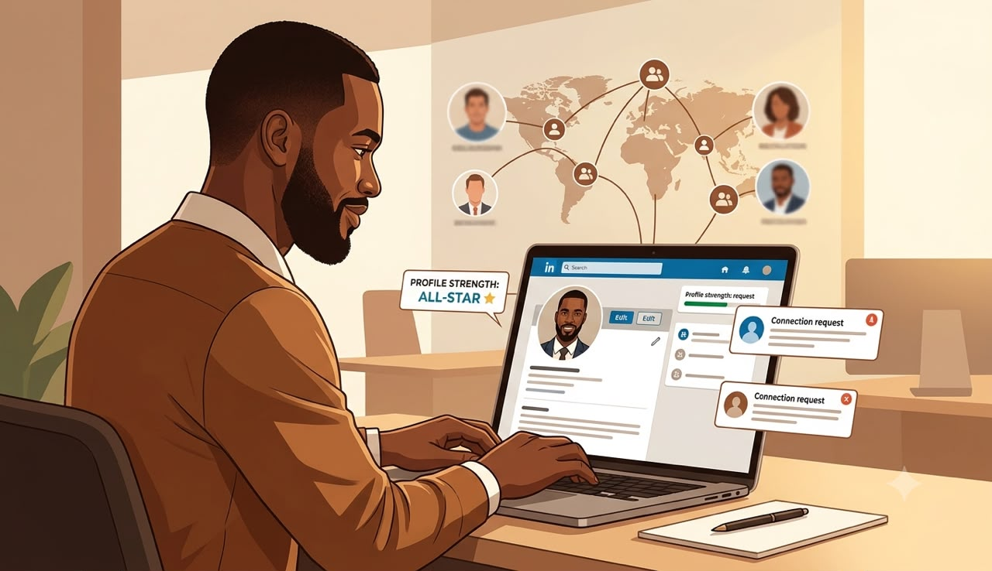
CHAPTER FIVE
Turn LinkedIn Into Your 24/7 Recruiter Magnet
Why Some People Get Invited Without Applying
Have you ever seen someone post:
"I wasn't even looking for a job. A recruiter contacted me on LinkedIn."
At first, I thought those people were simply lucky.
Then I started paying attention.
I noticed something.
Their LinkedIn profiles looked different.
Not flashy.
Not complicated.
Just complete.
Professional.
Easy to understand.
That's when I realized something important.
LinkedIn isn't just another social media platform.
It's the world's largest professional networking platform.
Many recruiters use it every day to search for candidates, verify applications, and learn more about potential hires.
Think of your LinkedIn profile as your online office.
If someone walked into your office today, what impression would they leave with?
That's exactly what your profile communicates.
________________________________________
Stop Treating LinkedIn Like Facebook
One mistake I see often is treating LinkedIn like every other social platform.
People rarely update it.
Some only log in when they're unemployed.
Others leave profiles half-finished for years.
Imagine opening a shop but never putting your products on display.
That's what an incomplete LinkedIn profile looks like.
The good news?
Fixing it doesn't require expensive software.
It requires intention.
________________________________________
Your Profile Photo Matters
Before anyone reads your experience, they usually see your photograph.
This doesn't mean you need a professional photographer.
A clear smartphone photo is often enough if it is:
• Well-lit.
• Sharp.
• Friendly.
• Professional.
• Taken against a simple background.
Avoid:
• Heavy filters.
• Sunglasses.
• Group photos.
• Cropped party pictures.
• Low-quality selfies.
You're introducing yourself as a professional—not trying to win a photography competition.
________________________________________
Your Headline Is Your Elevator Pitch
Many people use headlines like:
Student
Unemployed
Looking for Work
These don't tell recruiters what you can actually do.
Instead, describe your professional value.
Examples:
Customer Support Specialist | CRM Experience | Passionate About Solving Customer Problems
Virtual Assistant | Calendar Management | Email Support | Administrative Professional
Content Writer | SEO | Blog Writing | Research
Notice the difference.
The second version helps recruiters understand your skills immediately.
________________________________________
Write an "About" Section That Sounds Human
The About section is not the place to use buzzwords.
Instead of saying:
I am hardworking, honest, loyal, dedicated and passionate...
Show people what you actually do.
A simple structure works well.
Paragraph One
Who are you?
Example:
I'm a customer support professional with three years of experience helping businesses improve customer satisfaction through clear communication and problem-solving.
________________________________________
Paragraph Two
What value do you bring?
Example:
I enjoy helping teams build positive customer experiences while improving response times and resolving complex enquiries professionally.
________________________________________
Paragraph Three
What opportunities are you interested in?
Example:
I'm currently interested in remote customer support opportunities where I can contribute to a collaborative international team while continuing to grow professionally.
Simple.
Clear.
Professional.
________________________________________
Your Experience Should Match Your CV
One mistake recruiters notice quickly is inconsistency.
Imagine your CV says:
Customer Support Specialist
But LinkedIn says:
Administrative Assistant.
Or your employment dates don't match.
Small inconsistencies can create unnecessary questions.
Before applying for jobs:
Compare your CV and LinkedIn.
Ensure:
✔ Job titles match.
✔ Dates match.
✔ Responsibilities align.
✔ Achievements are consistent.
________________________________________
Showcase Your Skills
LinkedIn allows you to list your professional skills.
Don't add everything you've ever learned.
Focus on skills relevant to your target role.
For example, if you're applying for customer support positions:
• Customer Service
• Email Support
• CRM Software
• Conflict Resolution
• Communication
• Problem Solving
• Microsoft Office
• Google Workspace
Choose quality over quantity.
________________________________________
Build Your Network the Right Way
Many people believe networking means asking strangers for jobs.
It doesn't.
Networking means building professional relationships.
Start by:
• Following companies you admire.
• Connecting with recruiters in your industry.
• Sending polite, personalized connection requests.
• Commenting thoughtfully on professional discussions.
• Congratulating people on career achievements.
You don't need thousands of connections.
A smaller network of relevant professionals is often more valuable.
________________________________________
Stay Active Without Becoming Annoying
You don't have to post every day.
Even one thoughtful post each week can help keep your profile active.
Ideas include:
• A lesson you learned from a course.
• A book recommendation.
• A project you completed.
• An industry insight.
• A career milestone.
Avoid turning your profile into a motivational quote page.
Professional value attracts professional opportunities.
________________________________________
Ask for Recommendations
Recommendations add credibility to your profile.
If you've worked with:
• A manager.
• A colleague.
• A lecturer.
• A client.
• A volunteer coordinator.
Ask if they'd be willing to write a short recommendation about your work.
A genuine recommendation often carries more weight than self-praise.
________________________________________
Use the "Featured" Section
Many people ignore this feature.
If you've written articles, completed projects, created a portfolio, earned certifications, or published work, consider adding relevant examples to your Featured section.
This gives recruiters quick access to evidence of your skills.
________________________________________
Tool 1: LinkedIn Profile Audit Checklist
Complete this before applying for your next job.
Task Complete
Professional profile photo ☐
Custom headline ☐
About section completed ☐
Work experience updated ☐
Skills listed ☐
Education completed ☐
Contact information updated ☐
Featured section used (if applicable) ☐
Profile URL customized ☐
Open to Work settings reviewed ☐
Aim to complete every item.
________________________________________
Tool 2: Weekly LinkedIn Growth Planner
Monday
Review your profile.
Update anything that's outdated.
________________________________________
Tuesday
Connect with five professionals in your field.
________________________________________
Wednesday
Comment thoughtfully on three industry posts.
________________________________________
Thursday
Share one useful insight or learning experience.
________________________________________
Friday
Research companies that interest you.
Follow them and review their career pages.
________________________________________
Weekend
Reflect on your activity.
Did you build genuine relationships or simply send connection requests?
Quality interactions matter more than quantity.
________________________________________
Tool 3: Connection Message Template
When sending a connection request, keep it short and respectful.
Example:
Hello [Name], I came across your profile while researching professionals in the customer support field. I admire your experience and would appreciate connecting here on LinkedIn. Thank you.
Notice what this message doesn't do.
It doesn't ask for a job.
It doesn't demand a referral.
It simply opens the door to a professional connection.
________________________________________
Common LinkedIn Mistakes
Avoid these habits:
• Leaving your profile incomplete.
• Using an unprofessional photo.
• Copying motivational quotes instead of sharing meaningful insights.
• Sending generic connection requests.
• Ignoring recruiter messages.
• Letting your profile become outdated.
________________________________________
Chapter Five Challenge
Before moving to Chapter Six:
☐ Update your profile photo.
☐ Rewrite your headline.
☐ Complete your About section.
☐ Add at least five relevant skills.
☐ Connect with five professionals in your target industry.
☐ Follow ten companies you'd genuinely like to work for.
☐ Review your profile from the perspective of a recruiter.
________________________________________
Key Lessons from Chapter Five
Remember these principles:
1. LinkedIn is your professional storefront. Keep it current and complete.
2. Clarity beats cleverness. Tell recruiters what you do and the value you bring.
3. Consistency builds trust. Your LinkedIn profile should support—not contradict—your CV.
4. Networking is about relationships, not requests. Focus on meaningful professional connections.
5. Stay visible. Regular, thoughtful activity can help you remain on recruiters' radar over time.
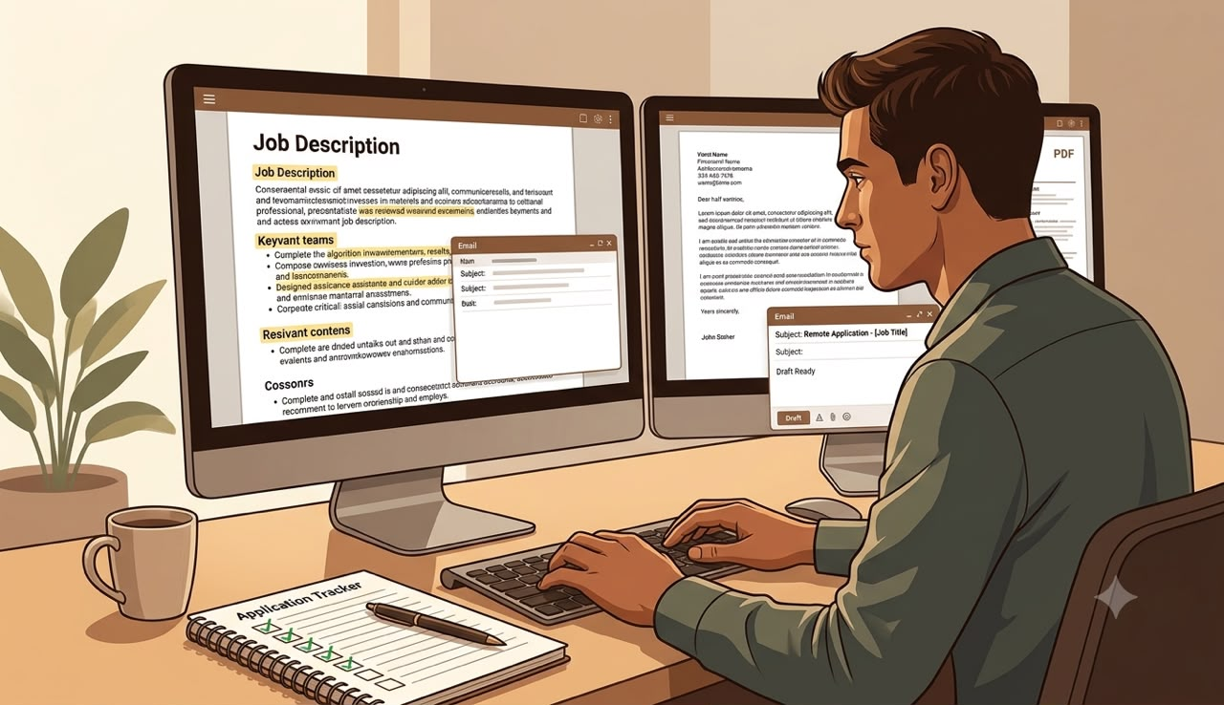
CHAPTER SIX
The Application System That Gets Responses
Don't Press "Apply" Just Yet
A mistake many job seekers make is treating every application the same.
They find a vacancy.
Attach the same CV.
Attach the same cover letter.
Click "Apply."
Repeat.
By Friday, they've sent fifty applications.
By the following Friday...
Nothing.
It's frustrating because they worked hard.
But effort alone isn't enough.
International employers aren't simply looking for people who are available.
They're looking for people who look like the right fit.
Your application should answer one question before the recruiter even meets you:
"Why should I interview this person instead of the other 200 applicants?"
That's what this chapter is about.
________________________________________
The 15-Minute Application Rule
Never apply immediately after finding a vacancy.
Instead, spend the first 15 minutes understanding the job.
Read the description carefully.
Ask yourself:
• What problem is this company trying to solve?
• Which skills appear repeatedly?
• Which qualifications are essential?
• Which are merely preferred?
• What kind of person are they describing?
These answers tell you exactly what your application should emphasize.
________________________________________
Read Like a Recruiter
Many applicants only look at the job title.
Recruiters read much more.
When reviewing a job description, highlight:
Responsibilities
These tell you what you'll actually be doing.
________________________________________
Required Skills
These are usually the minimum expectations.
If you meet most of them, the role may be worth pursuing.
________________________________________
Preferred Skills
These strengthen an application but aren't always mandatory.
Don't automatically reject yourself because you're missing one preferred skill.
________________________________________
Keywords
Notice words that appear several times.
For example:
Customer Experience
Communication
CRM
Problem Solving
Project Management
Time Management
These are clues about what the employer values.
Where appropriate and truthful, reflect these ideas naturally in your CV and cover letter.
________________________________________
Tailor Your CV
Remember your Master CV?
Now you'll use it.
Instead of rewriting everything, choose the experience most relevant to the role.
For example:
If you're applying for Customer Support,
emphasize:
• customer communication
• conflict resolution
• CRM systems
• problem solving
If you're applying for Virtual Assistant positions,
highlight:
• scheduling
• email management
• organization
• calendar coordination
Same person.
Different emphasis.
________________________________________
Write a Cover Letter That Sounds Human
Many cover letters begin like this:
"I wish to apply for the position..."
Recruiters have read that sentence thousands of times.
Instead, begin with genuine interest.
Example:
Dear Hiring Manager,
I was excited to see your opening for a Customer Support Specialist because the role closely matches the type of work I enjoy most—helping customers solve problems while creating positive experiences.
Immediately, the letter feels more personal.
________________________________________
A Simple Cover Letter Structure
You don't need complicated language.
Use this framework.
Paragraph One
Introduce yourself.
Mention the role.
Explain why you're interested.
________________________________________
Paragraph Two
Describe your most relevant experience.
Use one or two concrete examples.
________________________________________
Paragraph Three
Explain how your skills could benefit the company.
________________________________________
Paragraph Four
Close professionally.
Express appreciation.
Invite further discussion.
Simple.
Professional.
Easy to read.
________________________________________
Write Better Application Emails
Sometimes you'll email your application directly.
Keep your email brief.
Example:
________________________________________
Subject: Application for Customer Support Specialist
Dear Hiring Manager,
I hope you're doing well.
Please find attached my application for the Customer Support Specialist position advertised on your careers page.
I believe my background in customer service, communication, and problem-solving aligns well with the requirements of the role.
Thank you for your time and consideration.
I look forward to hearing from you.
Kind regards,
[Your Name]
________________________________________
Notice what isn't included.
No life story.
No unnecessary compliments.
No lengthy explanations.
Professional communication respects the reader's time.
________________________________________
Follow Up Professionally
Following up doesn't annoy employers when done respectfully.
If the job advert doesn't say otherwise, you may consider sending a polite follow-up after a reasonable amount of time if you haven't received a response.
Keep it short.
Example:
Dear Hiring Manager,
I hope you're well.
I'm writing to follow up on my application for the Customer Support Specialist position submitted on [Date].
I'm still very interested in the opportunity and would appreciate any update you can share.
Thank you for your time.
That's enough.
Don't send daily reminders.
One courteous follow-up is often sufficient unless the employer invites further communication.
________________________________________
Organize Every Application
If you're applying for several roles, organization becomes essential.
Create a folder for each application containing:
• Tailored CV
• Cover Letter
• Job Description
• Company Notes
• Confirmation Email
• Interview Notes (if invited)
When recruiters contact you later, you'll immediately remember what you applied for.
________________________________________
Tool 1: Job Description Analyzer
Before applying, complete this worksheet.
Job Title: _______________________
Company: _______________________
Required Skills
1. ________________________________________
2. ________________________________________
3. ________________________________________
Preferred Skills
1. ________________________________________
2. ________________________________________
3. ________________________________________
Keywords Used Repeatedly
________________________________________
My Relevant Experience
________________________________________
What Should I Highlight?
________________________________________
This five-minute exercise helps you tailor your application instead of guessing.
________________________________________
Tool 2: Cover Letter Builder
Complete the prompts below.
Opening
I'm applying for the position of __________________ because __________________.
Experience
My most relevant experience includes __________________.
Value
I believe I can help your organization by __________________.
Closing
Thank you for considering my application. I would welcome the opportunity to discuss how my experience aligns with your team's needs.
________________________________________
Tool 3: Application Tracker
Company Position Date Applied Follow-Up Date Interview Status

Update this table every time you apply.
It helps you stay organized and avoid duplicate applications.
________________________________________
Common Application Mistakes
Avoid these habits:
• Applying without reading the job description.
• Sending the same CV to every employer.
• Forgetting to rename your files professionally.
• Writing long, generic cover letters.
• Ignoring spelling and grammar.
• Applying for roles that clearly don't match your experience.
A thoughtful application often stands out more than a rushed one.
________________________________________
Chapter Six Challenge
Before moving to Chapter Seven:
☐ Analyze three job descriptions using the worksheet.
☐ Tailor your CV for one specific role.
☐ Write a personalized cover letter.
☐ Send one well-prepared application.
☐ Record it in your Application Tracker.
Focus on quality rather than volume.
________________________________________
Key Lessons from Chapter Six
Remember these principles:
1. Every application should reflect the role you're applying for.
2. Read job descriptions carefully before making changes to your CV.
3. A concise, personalized cover letter is usually more effective than a generic one.
4. Professional follow-ups show continued interest without becoming intrusive.
5. Organization helps you manage your search confidently and consistently.


CHAPTER SEVEN
Ace Remote Interviews Like a Professional
Congratulations—You've Reached a New Stage
If you've been invited to an interview, stop for a moment and appreciate what that means.
It means someone reviewed your application and decided you were worth speaking to.
Out of dozens—or sometimes hundreds—of applicants, you've made it to the next stage.
That's progress.
Now comes the next challenge.
Turning an interview into an offer.
________________________________________
Interviews Are Conversations—Not Interrogations
Many people think interviews are designed to expose weaknesses.
So they become nervous.
They memorize answers.
They try to sound perfect.
Ironically, that often makes them sound less natural.
Instead, think of an interview as a conversation between two people trying to answer the same question:
"Would we work well together?"
The employer wants someone who can solve problems.
You want a role that matches your skills and career goals.
Keeping that perspective can help reduce unnecessary pressure.
________________________________________
Preparation Begins Before the Interview
One of the easiest ways to stand out is simply to be prepared.
Before every interview, spend time learning about the company.
Visit its website.
Read the "About Us" page.
Understand:
• What products or services it offers.
• Who its customers are.
• Its mission or values (if available).
• Any recent news or updates.
This allows you to answer questions in a way that connects your experience to the company's needs.
________________________________________
Understand the Job Description Again
Go back and read the job description.
Ask yourself:
• Which responsibilities are most important?
• Which skills does the employer emphasize?
• Which examples from my experience best demonstrate those skills?
The interview is not the time to discover what the role involves.
Preparation starts beforehand.
________________________________________
The STAR Method
One of the simplest ways to answer behavioural interview questions is the STAR method.
It helps you give structured, easy-to-follow responses.
Situation
Briefly explain the context.
Task
Describe your responsibility.
Action
Explain what you did.
Result
Share the outcome.
________________________________________
Example
Question:
"Tell me about a time you dealt with a difficult customer."
Situation
A customer contacted our support team after receiving the wrong product.
Task
I needed to resolve the issue quickly while maintaining a positive experience.
Action
I apologized, confirmed the order details, arranged a replacement, and kept the customer informed throughout the process.
Result
The issue was resolved, and the customer later thanked our team for the prompt communication.
Notice how the answer is specific, structured, and easy to follow.
________________________________________
Common Interview Questions
You won't know every question in advance.
But you can prepare for the ones that appear most often.
Tell me about yourself.
Keep your answer focused on your professional background.
Don't start with where you were born.
Instead, explain:
• Who you are professionally.
• Relevant experience.
• Key strengths.
• Why you're interested in the role.
________________________________________
Why do you want this job?
Avoid saying:
"I need money."
Everyone works to earn a living.
Instead, connect your interests to the role.
For example:
"I'm interested in this position because it combines customer communication with problem-solving, which are areas where I've developed valuable experience and genuinely enjoy contributing."
________________________________________
What are your strengths?
Choose strengths that relate to the role.
Then support them with examples.
Instead of:
"I'm hardworking."
Say:
"One of my strengths is staying organized. In my previous role, I managed multiple customer requests while meeting response-time targets."
________________________________________
Tell me about a challenge you faced.
Use the STAR method.
Focus on:
• The situation.
• What you did.
• What you learned.
Avoid blaming colleagues or previous employers.
________________________________________
Questions You Can Ask the Interviewer
At the end of many interviews, you'll hear:
"Do you have any questions for us?"
Always prepare one or two thoughtful questions.
Examples:
• What does success look like in this role during the first six months?
• What qualities do your strongest team members have?
• How is performance measured?
• What opportunities are available for professional development?
These questions show genuine interest and help you evaluate whether the role suits you.
________________________________________
Preparing for Video Interviews
Remote interviews require a little extra preparation.
Before the interview:
✔ Test your internet connection.
✔ Charge your laptop.
✔ Test your microphone and camera.
✔ Choose a quiet location.
✔ Use good lighting.
✔ Keep your background clean and free from distractions.
Log in a few minutes early to check everything is working properly.
________________________________________
During the Interview
Remember these simple habits:
• Maintain eye contact by looking toward the camera.
• Speak clearly and at a comfortable pace.
• Listen carefully before answering.
• If you don't understand a question, politely ask for clarification.
• It's okay to pause briefly before responding.
You don't need to answer every question instantly.
Thoughtful responses are better than rushed ones.
________________________________________
After the Interview
The interview isn't necessarily over when the call ends.
Sending a brief thank-you email can leave a positive impression.
Keep it short.
Express appreciation for the interviewer's time.
Reaffirm your interest in the role.
Avoid repeating your entire interview.
________________________________________
Tool 1: Interview Preparation Worksheet
Complete this before every interview.
Company Name
________________________________________
Position
________________________________________
Interview Date
________________________________________
Company Mission
________________________________________
Main Responsibilities
________________________________________
Three Skills They're Looking For
1. ________________________________________
2. ________________________________________
3. ________________________________________
My Strongest Examples
Example 1:
________________________________________
Example 2:
________________________________________
Example 3:
________________________________________
________________________________________
Tool 2: STAR Answer Builder
Use this worksheet to prepare your stories.
Situation
________________________________________
Task
________________________________________
Action
________________________________________
Result
________________________________________
Prepare at least five STAR stories covering:
• Solving a problem
• Working in a team
• Handling pressure
• Managing conflict
• Learning something new
These examples can often be adapted to different interview questions.
________________________________________
Tool 3: Post-Interview Reflection
After each interview, answer these questions.
What went well?
________________________________________
What questions surprised me?
________________________________________
What could I improve?
________________________________________
What should I prepare better next time?
________________________________________
Reflection turns every interview into a learning opportunity.
________________________________________
Tool 4: Thank-You Email Template
Subject: Thank You for Today's Interview
Dear [Interviewer's Name],
Thank you for taking the time to speak with me today regarding the [Job Title] position.
I enjoyed learning more about your team and the role. Our conversation reinforced my interest in the opportunity and how my skills could contribute to your organization.
Thank you once again for your time and consideration. I look forward to hearing from you.
Kind regards,
[Your Name]
________________________________________
Common Interview Mistakes
Avoid these common pitfalls:
• Arriving late to virtual interviews.
• Speaking negatively about previous employers.
• Giving vague or overly long answers.
• Failing to research the company.
• Forgetting to prepare examples from your own experience.
• Treating the interview as a one-sided conversation.
Remember: interviews are as much about evaluating the company as they are about evaluating you.
________________________________________
Chapter Seven Challenge
Before moving to the final chapter:
☐ Prepare five STAR stories.
☐ Research one company thoroughly.
☐ Practice introducing yourself in under two minutes.
☐ Prepare three thoughtful questions to ask an interviewer.
☐ Send a thank-you email after your next interview.
These small habits can help you feel more prepared and confident when opportunities arise.
________________________________________
Key Lessons from Chapter Seven
1. Preparation builds confidence.
2. Structure your answers using the STAR method.
3. Research the company before every interview.
4. Professional communication continues after the interview.
5. Every interview is an opportunity to learn, regardless of the outcome.
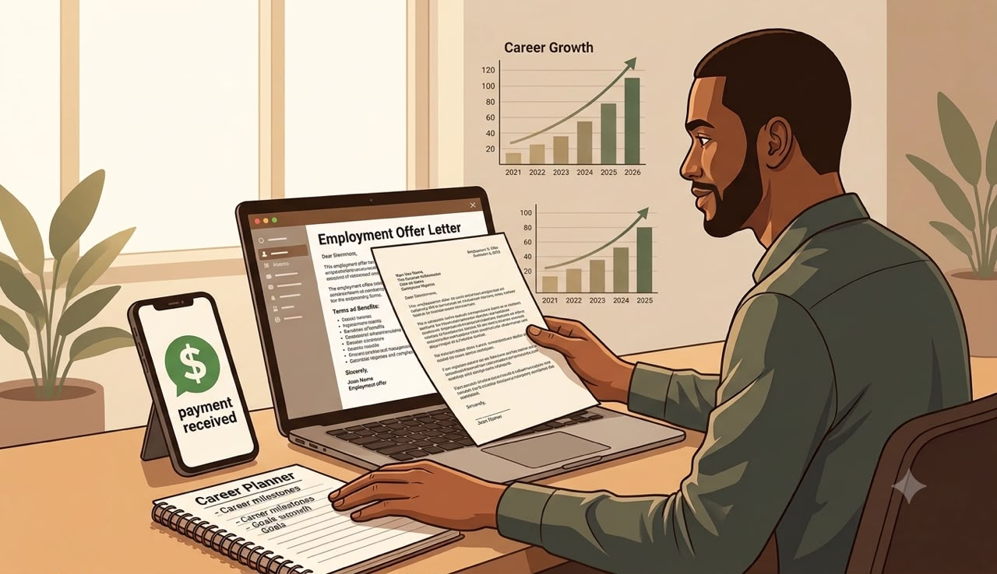
CHAPTER EIGHT
From Job Seeker to Remote Professional
This Is Not the Finish Line
If you've made it this far, you've already done something many job seekers never do.
You've stopped guessing.
You've built a system.
You've learned where to find opportunities, how to verify employers, how to strengthen your CV, optimize LinkedIn, submit better applications, and prepare for interviews.
Now comes the most important part.
Consistency.
Many people don't fail because they're unqualified.
They stop after a few weeks.
Remote job searching is rarely about one perfect application.
It's about building professional habits that compound over time.
________________________________________
Think Like a Professional, Not a Job Seeker
There's a subtle difference.
A job seeker waits for opportunities.
A professional prepares for them.
Professionals continue learning even when they're employed.
They update their CV before they need it.
They maintain relationships.
They improve their skills.
The goal isn't simply to get one remote job.
The goal is to build a career that continues to grow.
________________________________________
Talking About Money
Many people feel uncomfortable discussing salary.
They worry that asking for too much will cost them the opportunity.
Or they accept the very first figure offered without asking questions.
Instead, approach salary discussions as professional conversations.
When compensation comes up:
• Listen carefully.
• Understand the full package, not just the base pay.
• Consider responsibilities, benefits, working hours, and growth opportunities.
• If appropriate, ask whether there is flexibility in the offer.
Negotiation isn't about demanding more.
It's about understanding your value and communicating professionally.
________________________________________
Freelancing vs Employment
Throughout this guide we've discussed remote jobs, but you may also encounter freelance opportunities.
Both have advantages.
Remote Employment
Often provides:
• Regular income
• Structured responsibilities
• Ongoing collaboration
• Long-term stability
Freelancing
May offer:
• Greater flexibility
• Multiple clients
• Project-based work
• More control over your schedule
Neither option is automatically better.
Choose the path that best matches your goals, experience, and preferred way of working.
________________________________________
Pricing Your Freelance Services
One question many beginners ask is:
"How much should I charge?"
There isn't one correct answer.
Instead, consider:
• The complexity of the work.
• The time required.
• Your level of experience.
• The value you bring.
• Typical rates for similar services.
As your experience grows and your results become stronger, your pricing can evolve as well.
Avoid underpricing yourself simply because you're new.
At the same time, be realistic and willing to build trust through quality work.
________________________________________
Build a Personal Brand
Your reputation follows you.
Every project.
Every email.
Every interview.
Every deadline.
People remember professionals who:
• Communicate clearly.
• Deliver quality work.
• Meet deadlines.
• Solve problems.
• Treat others respectfully.
Over time, these habits become your personal brand.
And a strong reputation often leads to repeat opportunities and referrals.
________________________________________
Keep Learning
The remote work landscape changes.
New tools appear.
New skills become valuable.
Make learning part of your routine.
You don't need to master everything.
Focus on skills that support your career.
Examples include:
• Microsoft Excel
• Google Workspace
• AI productivity tools
• Project management software
• Communication skills
• Writing
• Customer service
• Data analysis
• Digital marketing
Small improvements made consistently can have a significant impact over time.
________________________________________
Tool 1: Your 30-Day Action Plan
Instead of wondering what to do each day, follow this roadmap.
________________________________________
Week 1 – Build Your Foundation
□ Organize your job-search folders.
□ Create your Master CV.
□ Update LinkedIn.
□ Set up job alerts.
□ Complete the Job Readiness Checklist.
□ Create your Application Tracker.
________________________________________
Week 2 – Apply Strategically
□ Analyze five job descriptions.
□ Tailor your CV for each application.
□ Write personalized cover letters.
□ Submit high-quality applications.
□ Track every application.
________________________________________
Week 3 – Grow Your Visibility
□ Connect with recruiters.
□ Engage professionally on LinkedIn.
□ Learn one new skill.
□ Update your portfolio if applicable.
□ Continue applying consistently.
________________________________________
Week 4 – Review and Improve
□ Evaluate your application results.
□ Improve your CV based on feedback.
□ Practice interview questions.
□ Continue networking.
□ Plan your next month's goals.
________________________________________
Tool 2: Weekly Success Tracker
Activity Target Completed
Applications Submitted 5 ____
CVs Tailored 5 ____
Cover Letters Written 5 ____
Recruiters Contacted 5 ____
LinkedIn Connections 10 ____
Skills Learned 1 ____
Interview Practice Sessions 2 ____
Remember: consistency matters more than perfection.
________________________________________
Tool 3: Professional Resource Toolkit
Keep these categories bookmarked for future use:
Job Search
• LinkedIn Jobs
• Indeed
• Wellfound
• Remote OK
• We Work Remotely
• Jobspresso
Learning
• Google Career Certificates
• LinkedIn Learning
• Coursera
• Microsoft Learn
Productivity
• Google Drive
• Microsoft OneDrive
• Notion
• Trello
Communication
• Zoom
• Google Meet
• Microsoft Teams
• Slack
Portfolio
• GitHub (technical projects)
• Behance (design)
• Personal website or portfolio platform (where relevant)
Choose the resources that fit your profession rather than trying to use everything.
________________________________________
Tool 4: Monthly Career Review
At the end of each month, answer these questions.
What worked well?
________________________________________
Which applications received responses?
________________________________________
Which skills should I improve next?
________________________________________
Which companies should I watch next month?
________________________________________
What is my biggest goal for the next 30 days?
________________________________________
Reviewing your progress regularly helps you adjust your strategy instead of repeating the same habits.
________________________________________
What Success Really Looks Like
Success doesn't always happen in one dramatic moment.
Sometimes it looks like:
• Receiving your first recruiter message.
• Getting invited to your first interview.
• Writing a stronger CV than you had last month.
• Building confidence during interviews.
• Learning a valuable new skill.
• Recognizing and avoiding a scam before it wastes your time.
These are all signs that you're moving forward.
Celebrate them.
They build momentum.
________________________________________
Your Commitment
Before you close this guide, make one commitment to yourself.
"I will focus on consistent improvement instead of quick fixes. I will apply strategically, continue learning, and treat every application as an opportunity to grow professionally."
Sign below.
Name:
________________________________________
Date:
________________________________________
Signature:
________________________________________
________________________________________
Final Words
When you started reading this guide, you may have been overwhelmed by the number of websites, opinions, and conflicting advice about remote work.
Now you have something more valuable than another list of tips.
You have a system.
Remember the framework we built together:
FIND
Identify quality opportunities instead of applying everywhere.
VET
Verify employers and protect yourself from scams.
GET HIRED
Present yourself professionally through stronger applications, interviews, and consistent follow-up.
No guide can promise a job offer.
But a clear system can help you make better decisions, improve your applications, and approach your remote job search with greater confidence and purpose.
Thank you for trusting me to be part of your journey.
I genuinely hope that the next interview invitation, the next recruiter message, or the next opportunity you receive is the beginning of something meaningful for your career.
Keep learning.
Keep improving.
Keep showing up.
Your next opportunity could be closer than you think.
________________________________________
THE END
Congratulations!

